**University Department Info Page**

**Submitted by:**

**Member 1**

**Name** : S Mehanath

**Reg no** : 2460645

**Mail Id** [:smehanath@btech.christuniversity.in](mailto:Id-smehanath@btech.christuniversity.in)

**Member 2**

**Name** : Tom Boby Alex

**Reg no** : 2462162

**Mail Id :** [tom.boby@btech.christuniversity.in](mailto:tom.boby@btech.christuniversity.in)

**Member 3**

**Name** : Nanda Krishnan

**Reg no** : 2462116

**Mail Id** : [nanda.krishnan@btech.christuniversity.in](mailto: nanda.krishnan@btech.christuniversity.in)

**Course** : UI/UX Design Fundementals

**Instructor name**: Narendra

**Institution Name**: Christ University Kengeri Campus

**Date of Submission**:11/08/2025

**1.Abstract:**

This project is all about building a visually appealing and persuasive one-page website to launch a product — whether it’s a gadget, an app, a book, or something entirely made up. The goal is to create a clean, modern design that highlights the product’s features, pricing, and user testimonials in a way that grabs attention and encourages visitors to take action, like buying or subscribing.

The page will include all the essential sections you'd expect on a great landing page: a bold hero section, a clear list of features with icons, user reviews with star ratings, simple pricing cards, a strong call-to-action button, and a footer with contact info. Along the way, we'll use CSS to add subtle transitions and consistent styling to keep everything polished and user-friendly.

There's also room for creativity — optional features like a countdown timer or comparison tables can be added to make the launch feel even more dynamic. By the end, the result should be a smooth, conversion-focused landing page that shows off both design and front-end development skills. The final package will include HTML, CSS, images, and a short README.

**2.Objectives**

* Create a compelling product promotion page using layout best practices.
* Emphasize calls-to-action using visual hierarchy.
* Display product features, pricing, and testimonials professionally.

3. **Scope of the Project**

This project involves the design and development of a one-page promotional website for a fictional product. The scope includes:

* Building a structured, responsive layout using HTML and CSS (with Flexbox or Grid).
* Designing key landing page components such as hero section, features, testimonials, pricing, CTA, and footer.
* Applying modern UI/UX design techniques to emphasize CTAs and improve user engagement.
* Implementing CSS hover effects and transitions for interactive elements.
* Ensuring consistent styling across buttons, cards, and layout elements
* Delivering all source files including HTML, CSS, images, and documentation.

**5. Tools & Technologies Used**

|  |  |
| --- | --- |
| Tools/Technology | Purpose |
| HTML | Structure and form Markup |
| CSS | Styling and Layout |
| VS Code | Code Editor |
| Chrome Dev tools | Testing and Responsive Design |

**6. HTML Structure Overview**

* Used semantic tags: <header>, <nav>, <main>, <section>, <footer>
* Structured into sections: Hero section, Features, Testimonials, Pricing, CTA, and Footer.
* Navigation menu using <ul> with anchor links for smooth scrolling

**7. CSS Styling Strategy**

* External CSS file: style.css
* Comments and sections for readability
* Techniques:
  + **Flexbox and Grid** for responsive layouts
  + **Hover effects and transitions** for interactivity

**8.Key features**

| **Feature** | **Description** |
| --- | --- |
| **Hero Section** | **A visually striking top section with product image, headline, and introductory text.** |
| **Features Section** | **Highlights 3–4 core product features using icons and short descriptions.** |
| **Testimonials** | **Showcases user feedback in card format with star ratings to build credibility.** |
| **Pricing Section** | **Displays pricing plans using tables or cards for clear comparison.** |
| **Call to Action (CTA)** | **Prominent buttons like "Buy Now" or "Subscribe" to prompt user interaction.** |
| **Footer** | **Contains company contact information and useful links (e.g., social, legal).** |
| **Responsive Layout** | **Designed using Flexbox or Grid to ensure the layout works across all devices.** |
| **CSS Transitions** | **Adds smooth hover effects and animations to enhance interactivity.** |
| **Consistent Styling** | **Uniform button, card, and typography design for a polished, professional look.** |
| **Optional Enhancements** | **Includes countdown timer or product comparison table for added value.** |

**9. Challenges Faced & Solutions**

|  |  |
| --- | --- |
| **Challenge** | **Solution** |
| **Accordion logic without JavaScript** | **Used HTML checkboxes + labels to simulate toggle effect for faculty section** |
| **Aligning and styling comparison panel content** | **Used Flexbox/Grid for uniform layout of course cards i.plan grid.** |
| **Image not loading correctly from local path** | **Realized absolute file paths (like C:\Users\...) won’t work on browsers—used relative path or hosted image instead.** |
| **Maintaining layout consistency across sections** | **Applied consistent CSS classes and spacing patterns (padding, margin).** |
| **Ensuring semantic structure** | **Used meaningful sectioning tags for better HTML5 practice and accessibility.** |

**10.The Outcome**

The Product Launch Page project was successfully completed, achieving all the intended objectives. The final result is a clean, modern, and responsive one-page website designed to effectively promote a fictional product. The layout is structured to guide users toward action through clearly emphasized call-to-action (CTA) elements and thoughtful visual hierarchy.

All key sections — including a hero banner, feature highlights, testimonial cards, pricing plans, and a footer — were implemented with attention to detail and design consistency. CSS transitions and hover effects were used to add interactivity without overwhelming the user experience. Buttons and cards maintain a uniform style, contributing to a professional and polished interface.

The landing page layout adapts seamlessly across devices using Flexbox and Grid, ensuring a smooth experience on desktops, tablets, and mobile phones. Optional enhancements like a CSS-only countdown timer were explored to add urgency and engagement.

Overall, the project demonstrates strong front-end development skills, attention to user experience, and the ability to deliver a functional and aesthetically pleasing product launch platform.

**11.Future Enhancements**

To further elevate the project and simulate real-world scalability, the following future improvements can be considered:

* Responsive Behavior Optimization:  
  Further refinement for performance and usability on various screen sizes and devices, including accessibility features.
* JavaScript Enhancements:  
  Introduce JavaScript-based features such as form validation, interactive sliders, or modals for better user experience.
* Live Product Demo Integration:  
  Embed a live video demo or animated product walkthrough to engage users more effectively.
* Newsletter Sign-up or Lead Capture:  
  Add a form for email collection to support marketing and user retention.
* Backend Integration:  
  Connect with a server or CMS to make pricing, testimonials, or product data dynamic and manageable.
* Analytics Integration:  
  Add tracking tools (like Google Analytics) to monitor user behavior and improve performance based on data.
* Dark Mode Support:  
  Offer theme-switching functionality for user preference and accessibility.

**THE PROGRAM**

**HTML:**

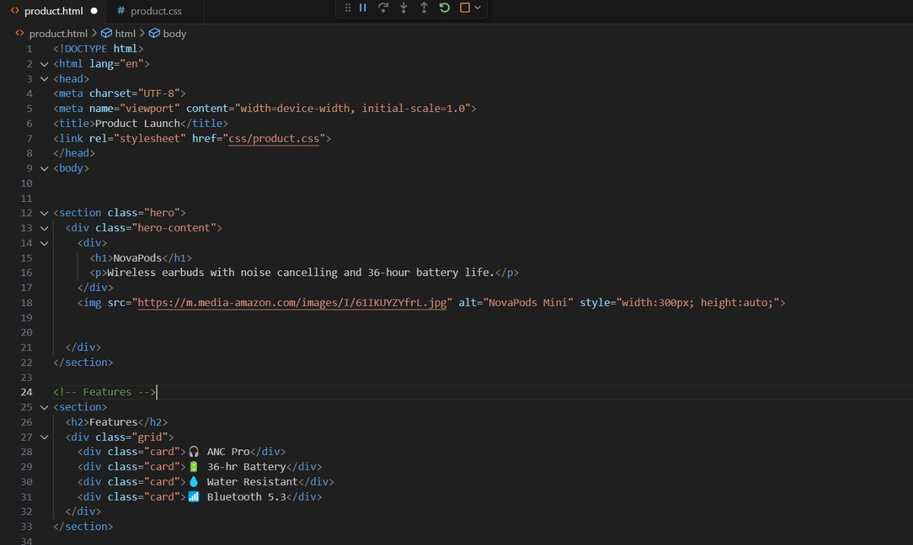

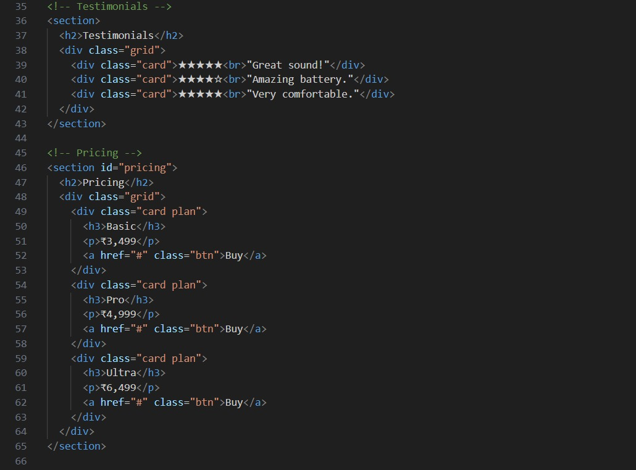

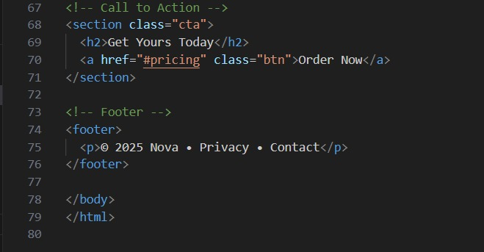

CSS:

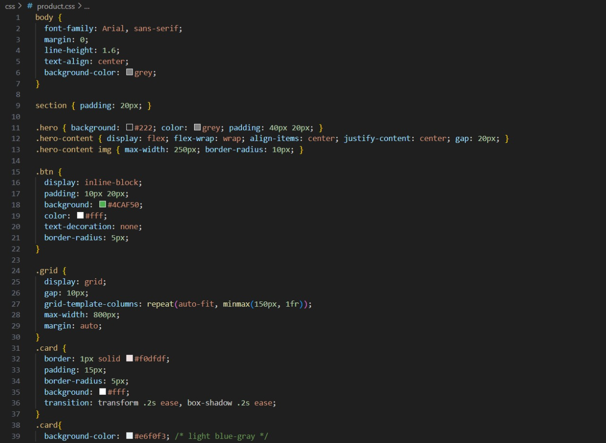

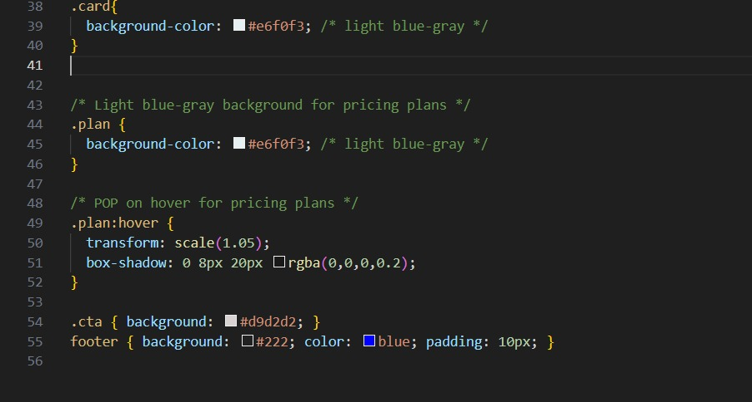

The Outcome:

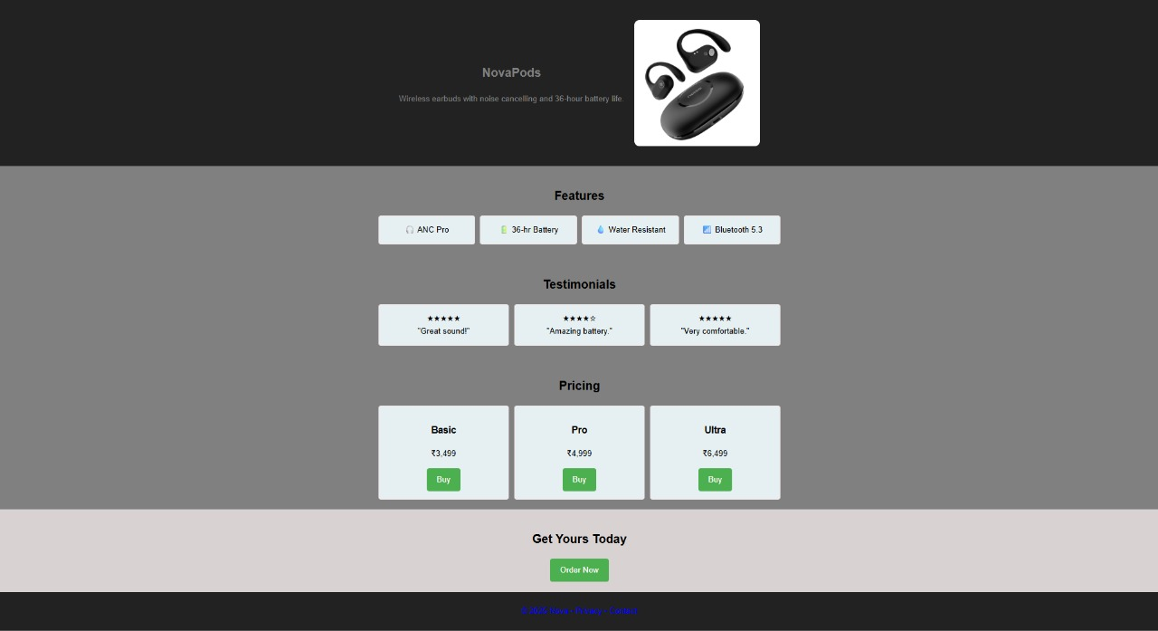

**The Conclusion:**  
The Product Launch Page project successfully applied modern web design principles and technical skills to create a visually appealing and conversion-focused landing page. Through the implementation of a clean layout, balanced whitespace, and well-placed calls-to-action, the page effectively communicates the product’s features, pricing, and testimonials. CSS hover transitions and consistent styling across buttons and cards enhanced interactivity and user engagement. The inclusion of structured sections—such as the hero banner, features, testimonials, and pricing—ensured clarity and ease of navigation. This project not only met the design guidelines and technical requirements but also provided hands-on experience in responsive layout techniques, component styling, and visual hierarchy, preparing for the development of professional-grade promotional web pages.